**Ex. No : 1 A**

**Date : 23.01.2025**

**IMPLEMENT CLIENT SIDE FORM DESIGN AND VALIDATION**

**AIM:**

To implement client side form design and validation to develop a login Page for the mini project.

**PROCEDURE:**

|  |  |  |
| --- | --- | --- |
| **S.NO** | **HTML TAGS** | **DESCRIPTION** |
| **1** | **<html>** | **The html tag in HTML is used to define the root of HTML and XHTML documents.** |
| **2** | **<a herf=” “> …</a>** | **create a hyperlink on the webpage.** |
| **3** | **<button type = “button”>** | **define the clickable button** |
| **4** | **<code>** | **define the piece of computer code.** |
| **5** | **<div>** | **make divisions of content in the web page** |
| **6** | **<footer>** | **define a footer of HTML document** |
| **7** | **<head>** | **define the head portion of the document which contains information related to the document.** |
| **8** | **<img src=”” alt=”” width=”” height=””>** | **add the image in HTML** |
| **9** | **<label>** | **provide a usability improvement for mouse users.** |
| **10** | **<meta attribute-name=”value”>** | **it provides important information about a document.** |
| **11** | **<em>** | **used to indicate the structural meaning of a block of text.** |
| **12** | **<script>** | **The script tag in HTML is used to define the client-side script.** |
| **13** | **<section>** | **defines the section of documents such as chapters, headers, footers, or any other sections.** |
| **14** | **<span>** | **The HTML span element is a generic inline container for inline elements and content.** |
| **15** | **<table>… </table>** | **HTML Table is an arrangement of data in rows and columns, or possibly in a more complex structure.** |
| **16** | **<video src=”” controls> </video>** | **HTML5 Video, along with knowing the different ways to add the videos to the HTML page.** |

**SOURCE CODE :**

<!DOCTYPE html>

<html lang="en">

<head>

<meta charset="UTF-8" />

<meta name="viewport" content="width=device-width, initial-scale=1.0" />

<title>Experiment 0</title>

<link rel="stylesheet" href="styles.css" />

</head>

<body>

<div class="wrapper">

<div class="title">

<h2 class="fugaz-one-regular">Login To Overflow</h2>

<hr />

<h3 class="roboto">Fill the below form to login</h3>

<div class="Oauth">

<button class="inter signin">

<img src="./src/google.svg" class="logo" />

Sign in with Apple

</button>

<button class="inter signin">

<img src="./src/apple.svg" class="logo" />

Sign in with Apple

</button>

</div>

<hr />

<h3 class="roboto">Email</h3>

<div class="inputContainer">

<input type="email" name="Password" id="Email" class="inter"/>

</div>

<h3 class="roboto">Password</h3>

<input type="password" name="Password" id="Password" class="inter"/>

<a class="forgotPassword roboto" href="./forgetPassword"

>Forget Password?</a>

<br />

<div class="buttonWrapper">

<button class="roboto submit">Submit</button>

</div>

</div>

</div>

</body>

</html>

**OUTPUT 1 :**

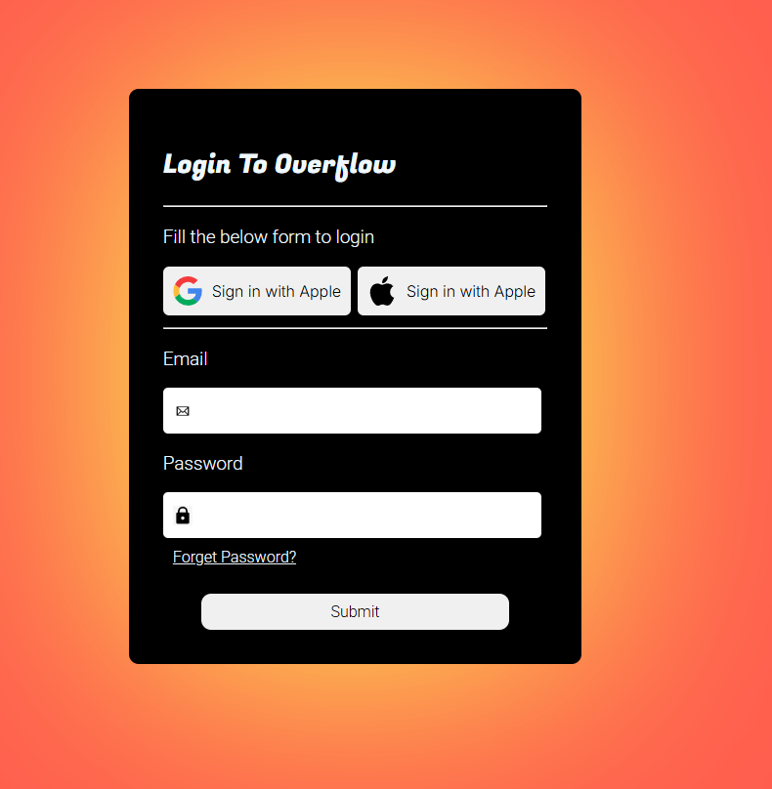

**RESULT :**

The program has been successfully executed and the output is verified.